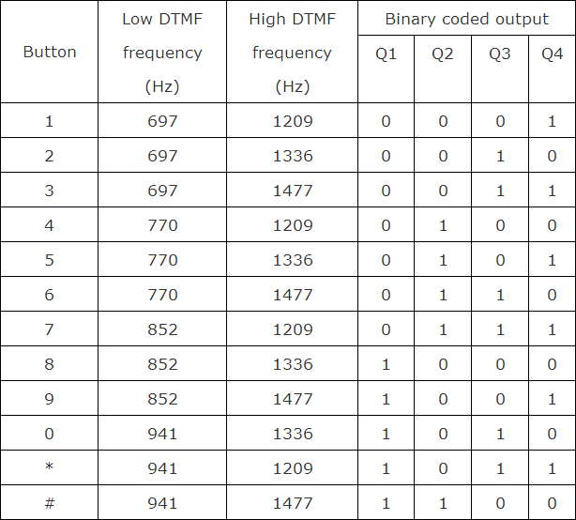

**Analog to digital decoder convertion**